**Institute of Fine Arts**

**PROJECT GROUP MEMBER**

|  |  |
| --- | --- |
| **Students Id** | **Students Name** |
| *Student1434943* | *Muhammad Mohtashim* |
| *Student1430194* | Hafiz Abdur Rafay |
| *Student1435114* | *Syed Muhammad Ibad* |
| *Student1435107* | *Shuja Abbas* |
| *Student1452991* | *Muhammad Azam* |
| *Student1431524* | Ameer Hamza |

**CURRICULUM BATCH**

**7062 2302B2**

**FACULTY**

**SIR HARIS NASEER**

**CO-ORDINATOR**

**MISS MAHA HAIDER**

**ADMIN REGISTER**

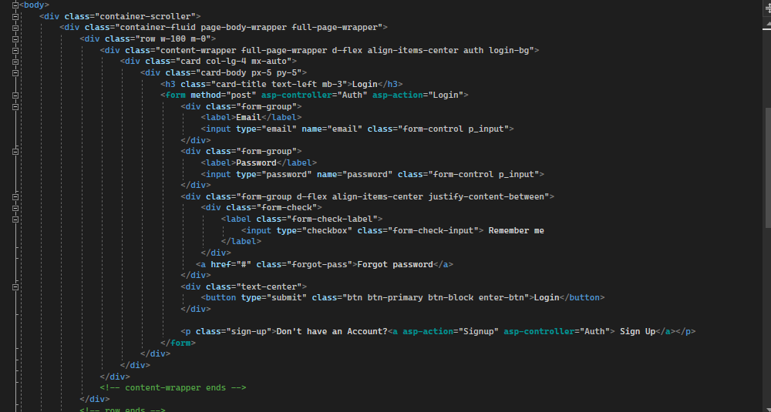

**ADD MANAGER**

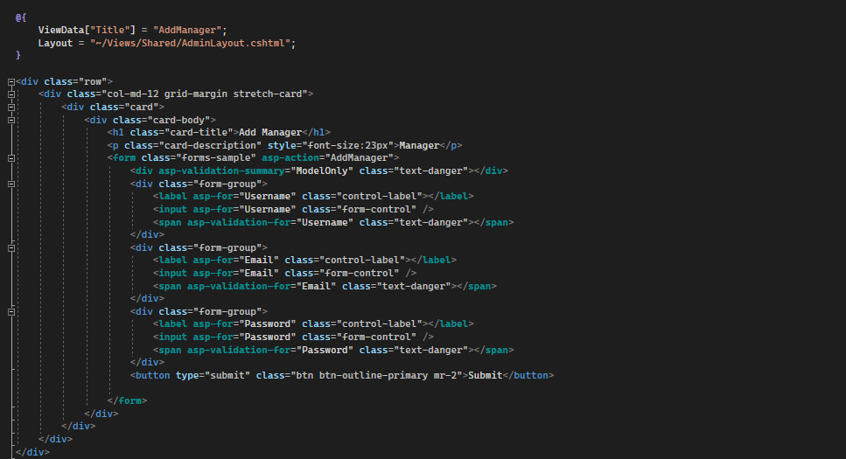

**VIEW MANAGER**

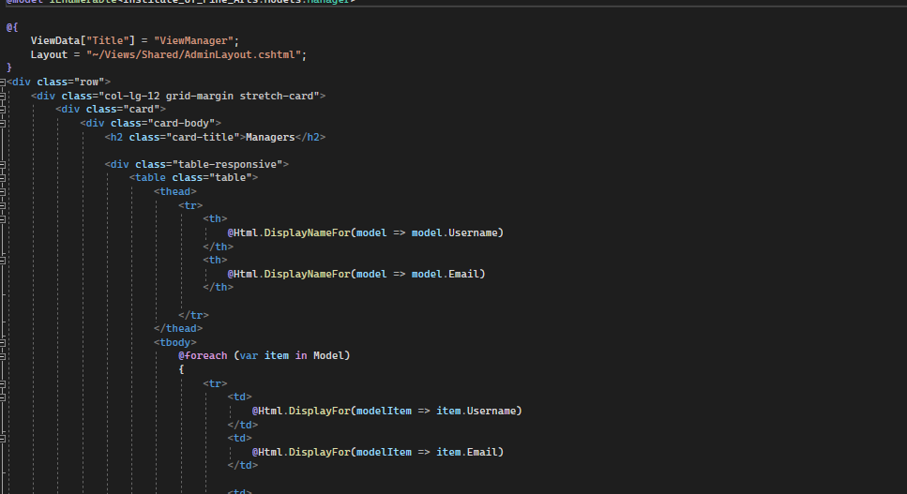

**SIGNUP**

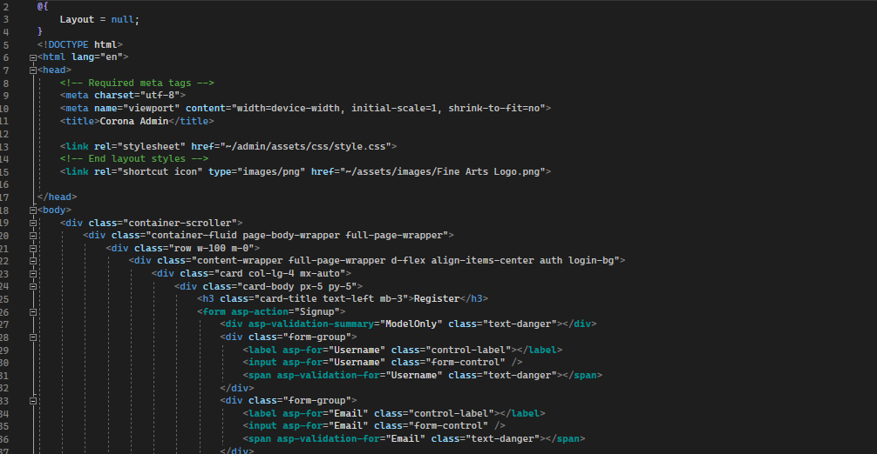

**LOGIN**

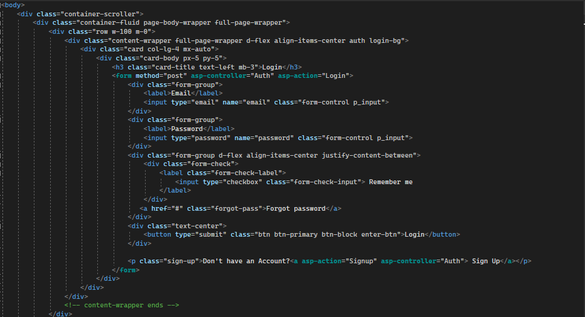

**HOME**

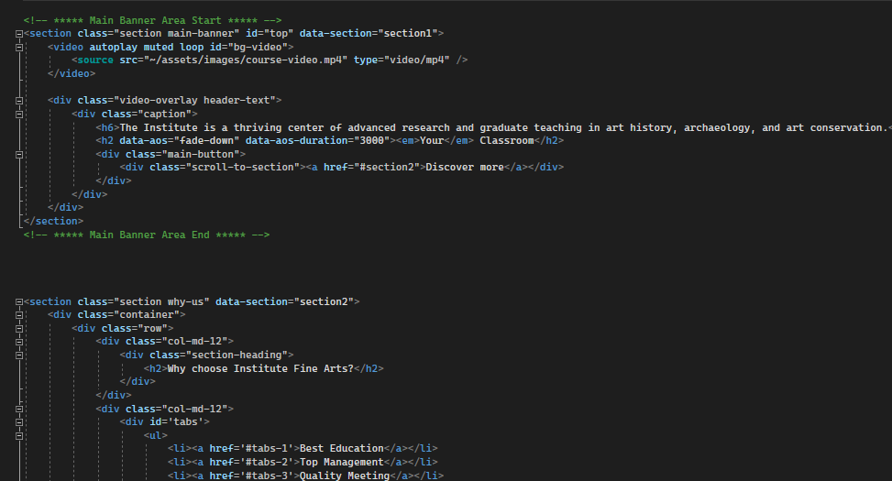

**ABOUT**

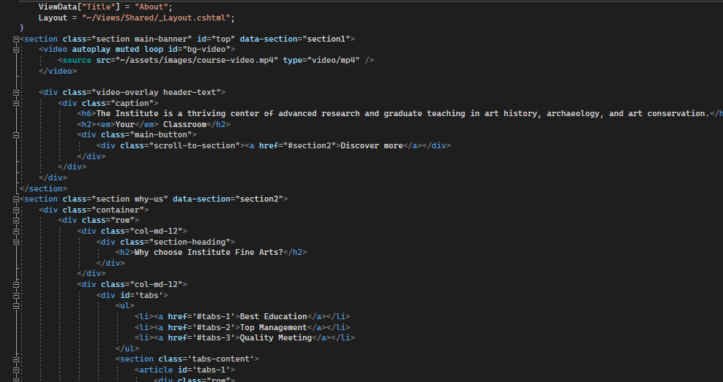

**COMPETITION**

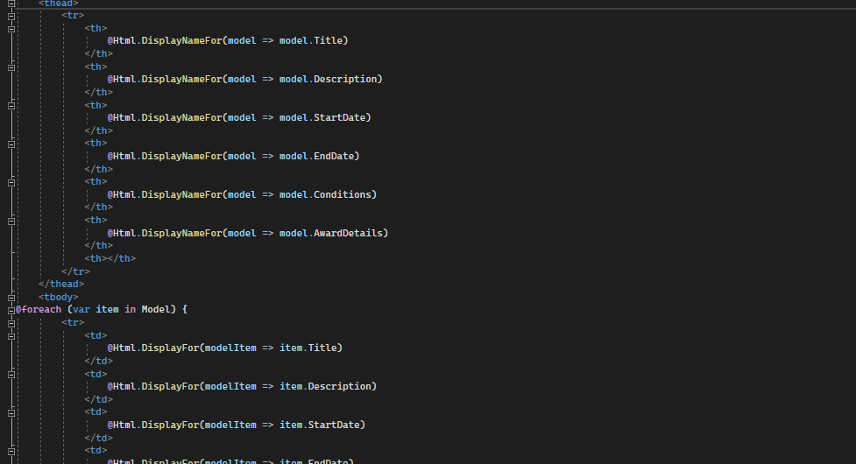

**COMPETITION DETAILS**

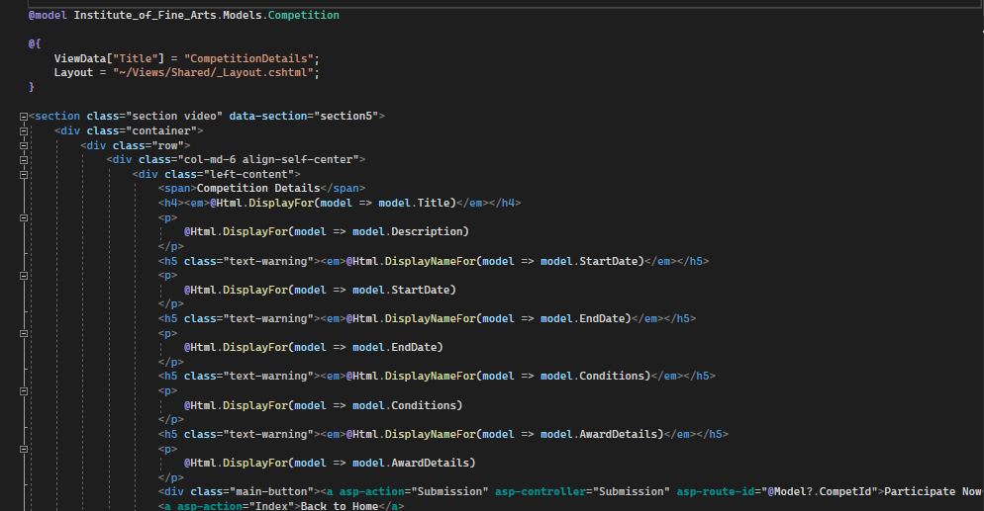

**CONTACT**

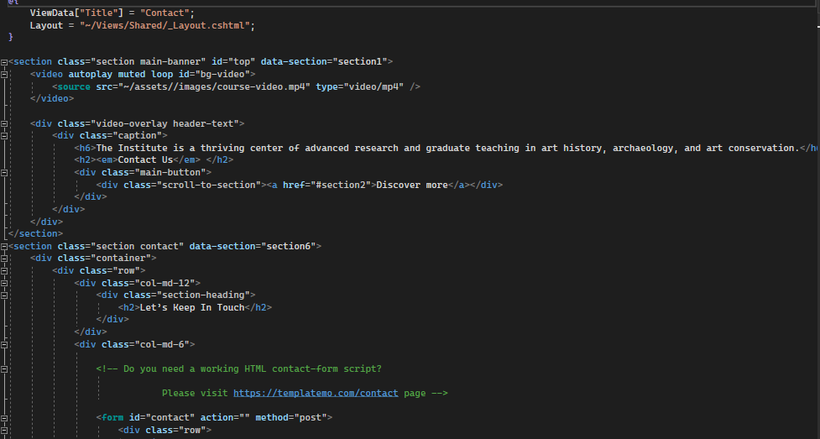

**DATABASE CONNECTION**

